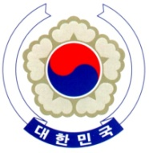
PERMANENT MISSION OF THE REPUBLIC OF KOREA
GENEVA
The 19th Session of UPR Working Group <Check against delivery>
Review of Ethiopia
Geneva, 6 May, 2014

Statement of the Republic of Korea

Thank you, Mr. President.

The Republic of Korea warmly welcomes the delegation of the Government of Ethiopia.

My delegation acknowledges that the Government of Ethiopia has made continuous efforts to promote and protect human rights since its first UPR.

In particular, we welcome the adoption of the ‘Ethiopian National Human Rights Action Plan’, the ratification of the International Convention of the Rights of Persons with Disabilities, and the anti-corruption initiative driven by the Federal Ethics and Anti-Corruption Commission.

Bearing this progress in mind, my delegation would like to offer the following two recommendations;

First, we recommend the Government of Ethiopia to fully implement the ‘Ethiopian National Human Rights Action Plan’.

Second, we recommend that Ethiopia take measures to ensure the increased freedom of expression of journalists and media workers.

Thank you, Mr. President. /End/

